**Connections with SAP DI 3.0**

1. **Data Service connection with SAP DI3.0**

Connection Details:

Host: 10.162.197.182

Port:6400

CMS Host: lkbods2:6400

CMS Port:6400

Username :  User01  
Password  :  Welcome01

Connection Error:

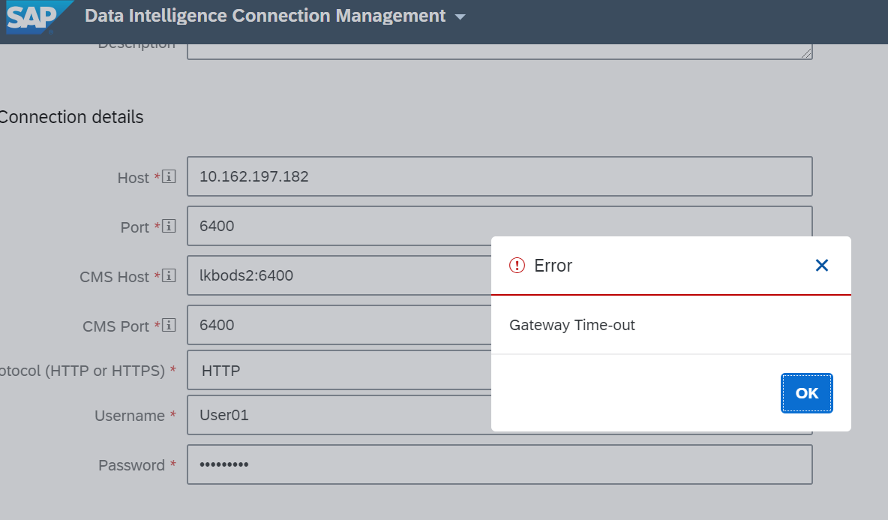

1. **SAP HANA**

|  |
| --- |
| HOST :10.162.197.181  Port:30015 |

|  |
| --- |
| Source: GH_SOURCE and Password: Welcome01  Connection Error: |

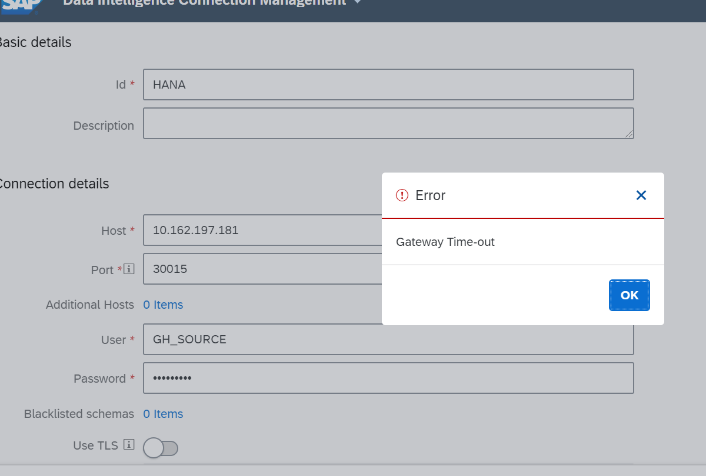

1. **BW/4 HANA**

Server: 10.162.197.132  
Port: 8101  
  
User: SUDHEER  
Password: Welcome123

Connection Error:

